Abstract—This article presents the progress of our autonomous robot whose purpose is to collect and sort rubbish to clean beaches. The robot is divided in two modules: One with a solid construction and four wheels to endure the sand variations on the ground, towing the second one that will collect and sort the garbage with the help of image recognition.
Beach Poly’bot
Hugo Denis--Martin, Eva Labauvie--Raffaelli

Index Terms—Beach Cleaner, Computer Vision, Ecofriendly, Mobile robots.

INTRODUCTION
Due to the overemployment of plastics in industry and the carelessness of customers, the seaboards have been buried under plastic rubbish, cigarette ends, and many other litter that shouldn’t be found on beaches.
Within the scope of our robotic project for the year 2022 to 2023, we decided, after acknowledging the state of the beaches around us, to set ourselves a challenge, and clean them.
It exists different types of beach cleaning robots, some using claws to collect trashcans [1], some others that would sift through sand to directly pick the plastic piece they are aiming for [2].
For our project, to begin with, we will need to achieve a robot capable to move itself in the sand even on slopes and that will be able to collect any rubbish even if it is slightly buried under some sand. Next, he will have to sort the collected rubbish, to avoid collecting inadvertently shells and other natural items that belongs to the beach.
In order to allow our robot to move, we had two possibilities of transmission with the ground: Using tracks or using wheels. Since the wheels are less expensive, quicker and easier to handle, it appeared they had more benefits than the tracks, which led us to save this solution. To set the wheels in motion, we considered different types of motors such as a direct-current motor, servo motor or step-by-step engine [3]. We ended up choosing a DC motor since it is the best price-to-output ratio, and it presents a considerable torque at low speed [4].
Further to these choices, we decided to separate the robot in two parts. At first, there will be, the towing device, which will be tackled in the first part of this article, and we will have the sorting device, detailed in the second part, before the conclusion.

Towing Robot

Body
As a first-year engineering robot, we were imposed to make a robot smaller than 20 x 36 mm so we made those exact dimension for the towing robot. It is composed of a laser cutted 5 mm wooden board (Figure 1), which we are planning to switch by an aluminum plate and a thermoformed cover in the future.
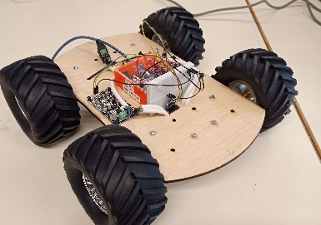
Fig 1- Towing Robot

Motors
As the robot function is to ride on sand, we have decided to have four-wheel drive (Figure 2) to always have a least 2 motors in contact with the ground. We found the motors we needed thanks to a simulator, we considered an 80° maximum slope, 70 rpm, 12V (from the battery), an estimation of 10kg for the whole robot, and therefore 0.5 Nm for each motor.
To operate the motors, we used two control board (h-bridge), one for those on the right, and one for those on the left. Those command cards are then drived by an Arduino chip.
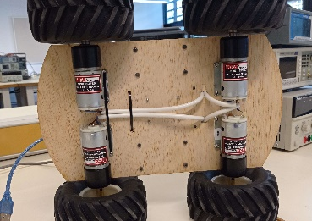
Fig.2- Four-wheel drive.
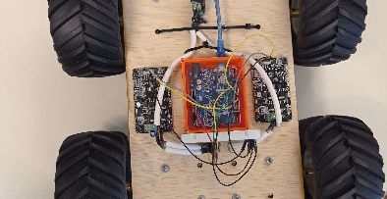
Fig.3- Control boards and Arduino.

Laser Detector
To avoid hurting someone on the way during the process, we have equipped a vl5310X laser to the robot, mounted on a two-axis mobile support (Figure 4), operated by two servomotors.
This laser scan if there is an obstacle in an area of 20cm in the front 180°. We use the Adafruit library to harness the laser in the code.

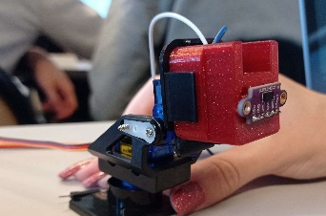
Fig.4- Laser on his two-axis mobile support.

Sorting Device
The sorting device is still in development but will soon be shaped.

Bucket-wheel excavator
In order to collect all the rubbish on the beach, we need a device that’s capable of picking sand and the items in it.
We have decided to inspire ourselves from the wheel excavators used in work sites.
It is a wheel with empty faces (Figure 5), there will be buckets attached to it and the collected items are supposed to fall on the grid. The sand will fall through the holes of the grid and only the collected items will stay in it, which will allow us to scan them using image recognition.

Image recognition
To use AI and be able to sort the rubbish the right way, we are using an Auvidea Jetson nano 30D card, powered by linux, that will allow us to recognize the rubbish we will scan with the camera attached with the card (Figure 5).

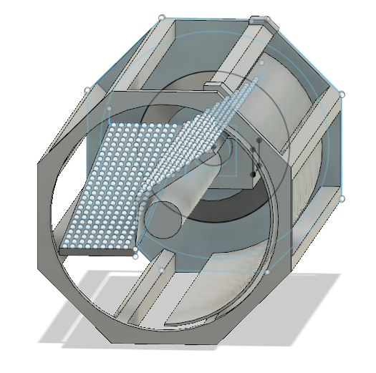
Fig.5- Model of the wheel on Fusion 360.

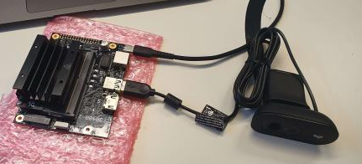
Fig.5- Auvidea card and the camera device.

Conclusion
We have made a robot composed of two parts, a towing and a collector/sorting part.
The towing part is composed of 4 motors powered by a 12V battery and operated by an Arduino card. The sorting part will collect garbage thanks to a bucketwheel and sort it with an image recognition.
References
- F.S da Rosa “Modular robot used as beach cleaner -Ingeniare. Revista chilena de ingeniería”, vol. 24 Nº 4, 2016, pp. 643-653.
- Hadiya Ebrahim, Wahaj Sheikh , Atif Saeed 3C Tecnología. Glosas de innovación aplicadas a la pyme. ISSN: 2254 – 4143 Edición Especial Special Issue Febrero 2022 DESIGN AND ANALYSIS OF SUSTAINABLE BEACH
- https://www.robotsforroboticists.com/drive-selection/.
- Complete motor guide
https://www.instructables.com/Complete-Motor-Guide-for-Robotics/#:~:text=A%20brushed%20DC%20motor%20is,push%2Dbutton%20adjustable%20car%20seats

Hugo Denis—Martin was born on November, the 9th 2002. Went to Lycée La Prat’s PT preparatory class in 2020. Currently in University Côte d’Azur, Polytech Nice, Robotics and autonomous systems since 2022

Eva Labauvie—Raffaelli was born on September the 4th 2001. Went to Lycée Masséna PSI preparatory class in 2019. Currently in University Côte d’Azur, Polytech Nice, Robotics and autonomous systems since 2022

 Hugo Denis--Martin is with the University Côte d’Azur, Polytech Nice, Robotics and autonomous systems department 06410 France e-mail: hugo.denis--martin@etu.univ-cotedazur.fr. Eva labauvie--Raffelli is with the University Côte d’Azur, Polytech Nice Robotics and autonomous systems department 06410 France e-mail: eva.labauvie--raffaelli@etu.univ-cotedazur.fr

